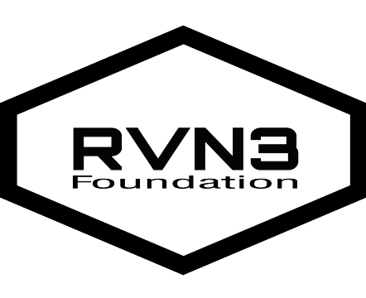
Sports and Activities Fee Application
Dicky Nielsen (928) 970-1550
Email: rvn3fndn@gmail.com
Facebook and Instagram: @rvn3foundation

Name: _____________________________ Date: ____________

Grade: ________ Gender: M ____ F____ Age: __________

Phone: _______________ Email: ________________________________________

Parent/guardian first and last name: ______________________

Sport or Activity: __________________________ Amount requested: $_________________

Does applicant qualify for free and reduced lunch? Y____N___

Annual income: _____________ Number of people in household: ______ Ages: ____________

How many extracurricular activities is applicant involved in? Please list ____________________________________________________________________________

Is applicant committed to attend a min of 80% of scheduled practices and games? Y___ N___

Is applicant willing to volunteer for upcoming RVN3 events? Y ____ N ____

Have the student fill out the following. Please provided 3-4 sentences on how has participating in sports or extracurricular activities have influenced you? ____________________________________________________________________________
________________________________________________________________________________________________________________________________________________________________________________________________________________________________________________________________________________________________________________________________________________________________________________________________________________________________________________________________________

Parent/Guardian signature: __________________________________

Student signature: ____________________________________

Deadline for applications is by the first game of the season!
APPLICATIONS MUST BE TURNED IN TO KEITH FAMILY FLOORING LOCATED AT
111 W. BONITA ST. PAYSON, AZ 85541

